Algorithms speed test

By Filippo Piloni and Alessandro Zanzi

Experiment 1, Experimentation & Evaluation 2023

# Abstract

Short (120-130 words) summary of your entire report. Give the reader a quick idea of what you did and what the main findings were (if you prepare this report ahead of time, leave out the findings until after you finish the analysis).

# 1. Introduction

Introduce the topic of investigation to the reader and motivate why you did the experiment. Note that in our case, writing “because I was told to by the course instructor” is not a valid answer. Please assume that you are trying to answer a certain relevant question and motivate its relevance. (In a “real” study report, you would need to also discuss any relevant prior research results here. Given our setting, however, we skip any “related work” consideration.) Your final paragraph of the introduction should outline your proposed experiment.

Sorting algorithms play a crucial role in various computer science applications, influencing the efficiency and performance of data processing tasks. It is important to choose the correct and faster algorithm according to the situation and cases of the program to maximize the efficiency. For this reason, the aim of this experiment is to demonstrate which among the three selected algorithms, namely, BubbleSortPassPerItem, BubbleSortUntilNoChange, and BubbleSortWhileNeeded, provides superior speed and efficiency? This inquiry drives the motivation behind our experiment, aiming to uncover the comparative performance of these algorithms and shed light on their behavior under varying conditions such as the size of the array, the type of the elements inside and the order of the elements.

The pursuit of this investigation is driven by a curiosity about the practical implications of sorting algorithms in real-world scenarios. Understanding the nuances of algorithmic behavior is essential for making informed decisions in software development, where optimal performance is often a critical factor.

The primary focus of our investigation is the evaluation of the three sorting algorithms in question, each representing a distinct approach to sorting. In this introduction, we provide a glimpse into the overarching goal of our experiment: to identify the algorithm that excels in terms of speed and efficiency.

In the subsequent sections, we will outline the experimental methodology, present the results, and draw conclusions based on our findings. By the end of this study, we aim to provide a clear understanding of the comparative strengths and weaknesses of the three algorithms considered.

|  |
| --- |
| **Hypotheses:** |
| Write down your (falsifiable!) hypotheses here. Each hypothesis must include **independent** and your **dependent** variables. You must write down your hypotheses **before** you do your experiment! |

# 2. Method

In the following subsections, describe everything that a reader would need to replicate your experiment in all important details.

## 2.1 Variables

Explicitly identify the independent variable(s) (i.e., what you as the experimenter manipulate):

|  |  |
| --- | --- |
| **Independent variable** | **Levels** |
| Algorithm  Length of the array to sort  Type of object in the array | PassPerItem, UntilNoChange, WhileNeeded  100, 1000, 10000  String, Integer, Byte |

Explicitly identify the dependent variable(s) (i.e., what you measure):

|  |  |
| --- | --- |
| **Dependent variable** | **Measurement Scale** |
| Time required to sort the array | Seconds |

Explicitly identify any important control variable(s) (i.e., what you keep constant): Note that you do *not* need to spell out items that you do not expect to make a *significant* difference! E.g., do not list room temperature unless you believe that minor differences have an impact! Only list variables here that you think are important to keep at a certain level.

|  |  |
| --- | --- |
| **Control variable** | **Fixed Value** |
| Elements of the array | Random values, Sorted values and inverted-sorted values |

## 2.2 Design

Check off the characteristics of your experimental design:

**Type of Study** (check one):

|  |  |  |
| --- | --- | --- |
| ⃞ **Observational Study** | ⃞ **Quasi-Experiment** | X **Experiment** |

The experimental design involves manipulating independent variables to observe their effects. Through randomization of groups, we aim to control extraneous variables and establish causal relationships between the independent variables and the observed outcomes.

**Number of Factors** (check one):

|  |  |  |
| --- | --- | --- |
| ⃞ **Single-Factor Design** | X **Multi-Factor Design** | ⃞ Other |

Explain, (1) in text using terminology from the book and lectures **and** (2) with a figure (similar to those used in Chapter 3 of the Field & Hole book), what kind of experiment you did.

The study incorporates multiple independent variables, forming a multi-factor design. This approach allows us to explore the interactions and combined effects of these variables, providing a more comprehensive understanding of the phenomena under investigation.

## 2.3 Apparatus and Materials

Describe in sufficient detail any relevant “props” that you used in your experiment. This could be the computer you used (exact model and specification), the software used (URL, version numbers), the way you measured, e.g., time (A stopwatch? A background process on the computer that got automatically triggered?). Omit needless detail (e.g., think whether details like the size of the table the laptop was placed on, or the hard disk size, might have affected your results or not).

* Computer Dell Precision 5550
* Java openjdk 17.0.8.1 2023-08-24
* Python 3.8.10

## 2.4 Procedure

Describe how you used your props and/or the participants to perform your actual experiment, i.e., how you actually carried out a single experimental run. What was done to the participants? What did they have to do? How long did each session take (unless this is an actual dependent variable)? If you did not have participants, explain, e.g., what software was started by whom in what order.

# 3. Results

## 3.1 Visual Overview

The graphs represent the time needed for the various algorithms to sort an array of different sizes of different types.

On the X axis are written the algorithm used.

On the Y axis is written the time in nanoseconds multiplied for the value on top of the axis (to improve visibility).

Type: Integer

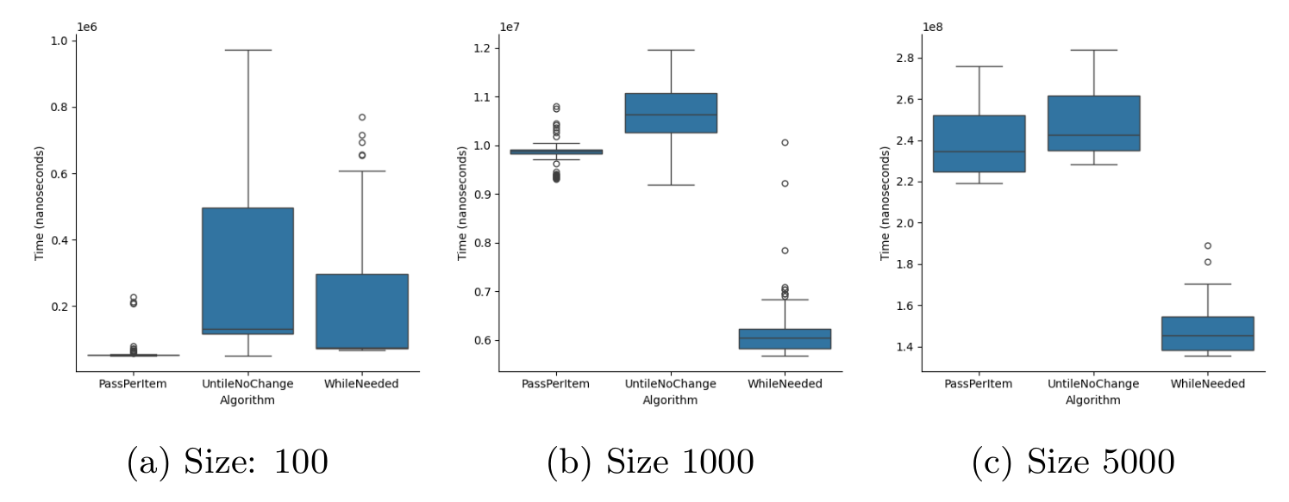

Type: Byte

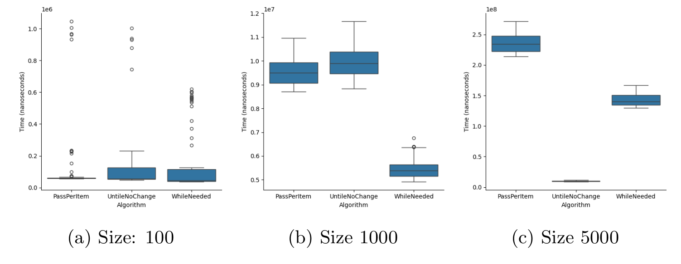

Provide an insightful overview of the data you collected. This requires some engineering from your part, to find a good degree of summarization: On one end of the spectrum, you don't summarize, and report hundreds of raw measurement values in a block of text. On the other end of the spectrum, you report a single number (like a mean value). Both approaches are bad.

Instead, use appropriate visual summaries (such as **scatter plots**, **histograms**, **box plots**, or **empirical cumulative distribution functions**) to show the distribution of your data. If you have a very small number of measurement values, then report all of them in a **well organized table** (where rows and/or columns correspond to different levels of different factors).

## 3.2 Descriptive Statistics

For each group or condition, summarize the set of measured values with a "five-number summary": **minimum**, **first quartile**, **median**, **third quartile**, and **maximum**.

Make sure you explain – in your words – what these statistics mean “in plain English”, but don’t yet interpret them (this is for the Discussion section).

# 4. Discussion

## 4.1 Compare Hypothesis to Results

Provide a brief restatement of the main results from the previous section, and if (or if not) these support your research hypothesis.

If there is a discrepancy between your hypothesis and the results of your experiment, speculate about why you were unable to find evidence to support your hypothesis.

## 4.2 Limitations and Threats to Validity

Acknowledge any faults or limitations your study has, and how seriously these affect your

results. How could these be remedied in future work?

## 4.3 Conclusions

End with the main conclusions that can be drawn from your study.

Appendix

# A. Materials

Any documents you used for your informed consent (information sheets, consent) or as part of your apparatus (e.g., manual, hand-out), please include them here.

# B. Reproduction Package (or: Raw Data)

Before, during, and after the experiment you collected all kinds of data. Don't ever throw such data away! Any plots, tables, summaries, and statistics provided in this report should be recreatable from the raw data you have.

If you only collected a small amount of data, put it in this Appendix right here.

If you collected data in forms that are better kept in separate files, then zip up those files, and submit them as a "reproduction package" supporting this report.